PRACTICAL 11: Compare AI vs Human Writing

Aim

To compare AI-generated content with student-created content.

Objectives
•To identify difference in writing
•To understand AI limitations

Materials Required
•AI tool

Procedure
1. Write paragraph manually
Compose a paragraph yourself using your own ideas, wording, and structure on the selected topic.

2. Generate same topic using AI
Use an AI tool to produce another paragraph on the same topic for comparison.

3. Create comparison table
Organize both paragraphs side-by-side in a table to compare style, clarity, tone, and content differences.

Output:

Topic: Will AI replace jobs or change them?

a) Human-Generated (Student-Written) Paragraph (Approx. 120 words)
Artificial Intelligence will not completely replace jobs, but it will change the way people work. Many routine and repetitive tasks are now done by machines, which saves time and increases efficiency. However, humans are still needed for creativity, decision-making, emotional intelligence, and problem-solving. AI can help doctors diagnose diseases, assist teachers in preparing lessons, and support engineers in design work. This means new job roles will be created, and existing jobs will require new skills. People will need to learn how to work with AI rather than fear it.

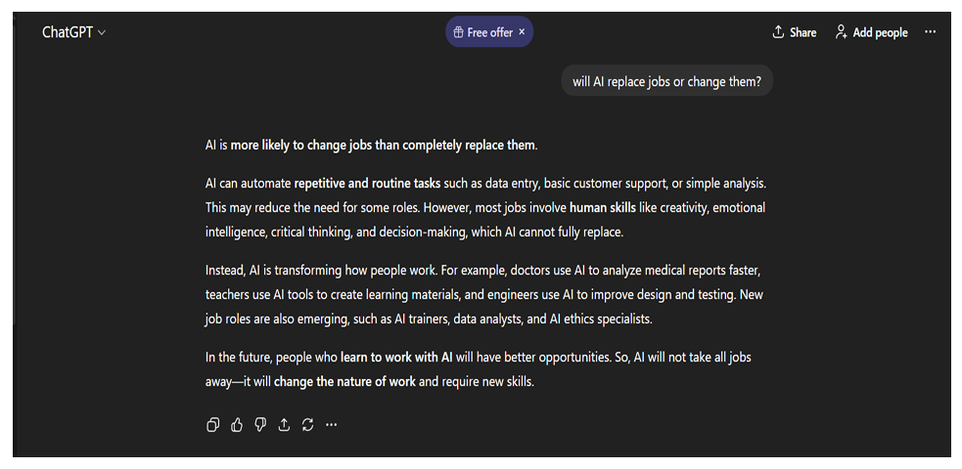
b) AI-Generated Paragraph (Written by ChatGPT)

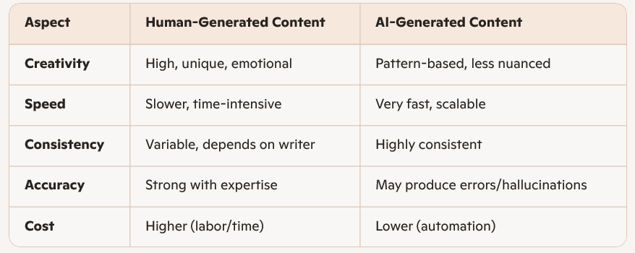
c) Comparison Table

